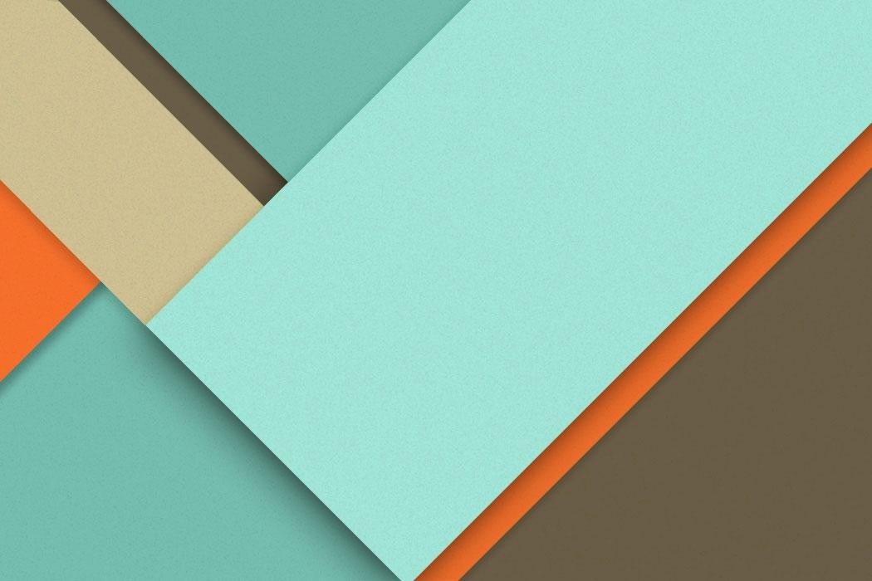
CS-457 Digital Image Processing
Practical Task 08
5.12.2024
─ 1
Task 1:
Download any grayscale image of your choice and change the resolution to 1000x1000. Display the image.
- Add 5% salt and pepper noise in the image. Display the noisy image.
- Add 5% uniform noise and display the image.
- Add 5% Gaussian noise and display the image.
- Using 3x3, 7x7, and 11x11 kernels (with equal weights), filter all the noisy images produced above and show the outputs.
- Using 5x5 window, generate the results for the following order statistic filters for the salt and pepper image: Min, Max, Median, Midpoint, Alpha Trimmed (with k=2).
- For the salt and pepper image, using 3x3 window, perform geometric mean filtering and show the output.
import numpy as np import cv2 import matplotlib.pyplot as plt # Function to add different types of noise def add_salt_and_pepper_noise(image, noise_percentage=0.05):
noisy_image = np.copy(image) total_pixels = image.shape[0] * image.shape[1] num_noise_pixels = int(total_pixels * noise_percentage)
# Salt noise (white pixels) salt_coords = [np.random.randint(0, i, num_noise_pixels // 2) for i in
image.shape[:2]]
noisy_image[salt_coords[0], salt_coords[1]] = 255
# Pepper noise (black pixels) pepper_coords = [np.random.randint(0, i, num_noise_pixels // 2) for i in image.shape[:2]]
noisy_image[pepper_coords[0], pepper_coords[1]] = 0 return noisy_image
def add_uniform_noise(image, noise_percentage=0.05):
noise = np.random.uniform(-50, 50, image.shape).astype(np.uint8) noisy_image = cv2.add(image, noise) return noisy_image
def add_gaussian_noise(image, noise_percentage=0.05, mean=0, sigma=25): noise = np.random.normal(mean, sigma, image.shape).astype(np.uint8) noisy_image = cv2.add(image, noise) return noisy_image
def uniform_filter(image, kernel_size):
kernel = np.ones((kernel_size, kernel_size)) / (kernel_size * kernel_size) filtered_image = cv2.filter2D(image, -1, kernel) return filtered_image
def order_statistic_filters(image, window_size=5):
# Pad the image pad = window_size // 2 padded_image = cv2.copyMakeBorder(image, pad, pad, pad, pad,
cv2.BORDER_REFLECT) # Prepare output images min_filter = np.zeros_like(image) max_filter = np.zeros_like(image) median_filter = np.zeros_like(image) midpoint_filter = np.zeros_like(image) alpha_trimmed_filter = np.zeros_like(image) for i in range(pad, padded_image.shape[0] - pad):
for j in range(pad, padded_image.shape[1] - pad):
window = padded_image[i-pad:i+pad+1, j-pad:j+pad+1]
# Min filter min_filter[i-pad, j-pad] = np.min(window)
# Max filter max_filter[i-pad, j-pad] = np.max(window)
# Median filter
median_filter[i-pad, j-pad] = np.median(window)
# Midpoint filter midpoint_filter[i-pad, j-pad] = (np.min(window) + np.max(window)) / 2
# Alpha-trimmed mean filter (k=2) sorted_window = np.sort(window.flatten()) alpha_trimmed_filter[i-pad, j-pad] = np.mean(sorted_window[2:-2])
return min_filter, max_filter, median_filter, midpoint_filter,
alpha_trimmed_filter def geometric_mean_filter(image, window_size=3):
# Pad the image pad = window_size // 2 padded_image = cv2.copyMakeBorder(image, pad, pad, pad, pad,
cv2.BORDER_REFLECT)
filtered_image = np.zeros_like(image) for i in range(pad, padded_image.shape[0] - pad):
for j in range(pad, padded_image.shape[1] - pad):
window = padded_image[i-pad:i+pad+1, j-pad:j+pad+1]
# Geometric mean geometric_mean = np.prod(window) ** (1 / (window_size *
window_size)) filtered_image[i-pad, j-pad] = geometric_mean
return filtered_image.astype(np.uint8)
# Main execution def main():
# Read image and convert to grayscale image = cv2.imread('/content/Img.jpg', cv2.IMREAD_GRAYSCALE)
# Resize image to 1000x1000 image_resized = cv2.resize(image, (1000, 1000),
interpolation=cv2.INTER_AREA)
# Original image
plt.figure(figsize=(15, 10)) plt.subplot(4, 6, 1) plt.title('Original Image') plt.imshow(image_resized, cmap='gray')
plt.axis('off')
# a) Salt and Pepper Noise salt_pepper_noisy = add_salt_and_pepper_noise(image_resized) plt.subplot(4, 6, 2) plt.title('Salt & Pepper Noise') plt.imshow(salt_pepper_noisy, cmap='gray')
plt.axis('off')
# Filtering salt & pepper noisy image with different kernels kernel_sizes = [3, 7, 11] for idx, k_size in enumerate(kernel_sizes, 3):
filtered = uniform_filter(salt_pepper_noisy, k_size) plt.subplot(4, 6, idx) plt.title(f'Salt & Pepper\n{k_size}x{k_size} Kernel') plt.imshow(filtered, cmap='gray') plt.axis('off')
# b) Uniform Noise uniform_noisy = add_uniform_noise(image_resized) plt.subplot(4, 6, 6) plt.title('Uniform Noise') plt.imshow(uniform_noisy, cmap='gray')
plt.axis('off')
# Filtering uniform noisy image with different kernels for idx, k_size in enumerate(kernel_sizes, 7): filtered = uniform_filter(uniform_noisy, k_size) plt.subplot(4, 6, idx) plt.title(f'Uniform\n{k_size}x{k_size} Kernel') plt.imshow(filtered, cmap='gray') plt.axis('off')
# c) Gaussian Noise gaussian_noisy = add_gaussian_noise(image_resized) plt.subplot(4, 6, 11)
plt.title('Gaussian Noise') plt.imshow(gaussian_noisy, cmap='gray')
plt.axis('off')
# Filtering Gaussian noisy image with different kernels for idx, k_size in enumerate(kernel_sizes, 12): filtered = uniform_filter(gaussian_noisy, k_size) plt.subplot(4, 6, idx) plt.title(f'Gaussian\n{k_size}x{k_size} Kernel') plt.imshow(filtered, cmap='gray') plt.axis('off')
# e) Order Statistic Filters on Salt & Pepper Noise min_f, max_f, median_f, midpoint_f, alpha_f =
order_statistic_filters(salt_pepper_noisy)
filter_names = ['Min', 'Max', 'Median', 'Midpoint', 'Alpha Trimmed'] filters = [min_f, max_f, median_f, midpoint_f, alpha_f] for idx, (name, filt) in enumerate(zip(filter_names, filters), 16):
plt.subplot(4, 6, idx) plt.title(f'{name} Filter') plt.imshow(filt, cmap='gray') plt.axis('off')
# f) Geometric Mean Filter on Salt & Pepper Noise geometric_mean = geometric_mean_filter(salt_pepper_noisy) plt.subplot(4, 6, 21) plt.title('Geometric Mean Filter') plt.imshow(geometric_mean, cmap='gray')
plt.axis('off') plt.tight_layout() plt.savefig('noise_processing_results.png') plt.show() if __name__ == "__main__":
main()
